Question 1: What is the difference between 'Paste' and 'Paste Special' in Excel? Briefly explain with examples.

Ans:- n Excel, "Paste" (Ctrl+V) replicates everything from the copied data, including values, formulas, and formatting, whereas "Paste Special" offers granular control, allowing you to choose specific elements to paste, such as only values, formulas, formats, or to transpose data, resulting in a static or selectively linked paste rather than a complete replica.

Paste (Ctrl+V)

* **What it does:** When you perform a standard paste, Excel copies the entire content of the source cell(s) or range, including its data, formulas, number formats, comments, and all other associated formatting.
* **When to use it:** Use this when you want an exact replica of the original data, preserving all its original properties in the new location.

Example:

* **Cell A1:** Contains the formula =SUM(B1:C1) and is formatted as currency.
* **Cell A2:** Contains the text "Total".
* When you copy A1 and A2 and then paste them into A4 and A5 using Ctrl+V, the destination cells will contain the formula =SUM(B1:C1) in A4 and the text "Total" in A5, with both cells retaining their original currency and default formatting.

Paste Special

* **What it does:** This feature opens a dialog box (or a dropdown menu in newer versions) that presents various options for what to paste. You can choose to paste:
  + **Values:** Copies only the calculated results of a formula, discarding the original formula itself.
  + **Formulas:** Copies the formula, similar to a standard paste, but without the number formatting.
  + **Formats:** Copies only the formatting (like font, color, borders) without any data or formulas.
  + **Comments:** Copies only the cell comments.
  + **Validation:** Copies data validation criteria.
  + **Transpose:** Swaps rows and columns of the copied data.
  + **Paste Link:** Creates a dynamic link to the original data.
* **When to use it:** Use Paste Special when you need more control over the pasted data, such as when you want to:
  + Remove formulas and keep only the results.
  + Transfer a formula to a new location without its formatting.
  + Copy only the visual style of cells.
  + Rotate data from rows to columns.

Example:

* Using the same data as in the previous example (Cell A1 with =SUM(B1:C1) formatted as currency, and A2 with "Total").
* If you copy A1 and then use Paste Special > Values, cell A4 will contain the result of the formula (e.g., "0" if B1 and C1 are empty) without the formula itself.
* If you use Paste Special > Formats, cell A4 will be formatted as currency, but will not contain the SUM formula.
* If you copy A1 and A2, and then use Paste Special > Transpose, the content will be rearranged to place "Total" (from the row) into the column and the formula into the row, or vice versa.

Question 2: Describe the functions and usefulness of 'Freeze Panes' and 'Split Panes' in Excel.

Ans:- In Excel, Freeze Panes locks selected rows and/or columns in place so they remain visible while you scroll through the rest of the worksheet, which is useful for keeping headers in view on large datasets. Split Panes, on the other hand, divides the worksheet window into two or four independent scrolling sections, allowing you to view different parts of the same worksheet simultaneously, but the same data appears in each scrollable pane.

Freeze Panes

* **Function:** Locks specific rows and/or columns so they stay visible as you scroll.
* **Usefulness:**
  + **Contextual Clarity:** Keeps header rows or key identifying columns visible when working with large spreadsheets.
  + **Improved Navigation:** Makes it easier to find and analyze data by preventing essential information from disappearing off-screen.
  + **Data Integrity:** Ensures you don't lose track of what each column or row represents.

Split Panes

* **Function:** Divides the worksheet window into multiple panes (up to four) that can be scrolled independently.
* **Usefulness:**
  + **Simultaneous Viewing:** Allows you to view and compare different areas of the same worksheet at the same time.
  + **Data Entry:** Can be used to view related data in one pane while performing data entry in another.

Key Difference

* **Freeze Panes**: maintains fixed, static rows and columns.
* **Split Panes**: creates multiple, independent views of the same worksheet, with each new window duplicating the data.

Question 3: Explain the difference between inserting a new row and inserting a new column in Excel. Can you insert multiple rows or columns at once?

Ans:- In Excel, inserting a new row adds a horizontal block of cells above the selected row, while inserting a new column adds a vertical block of cells to the left of the selected column. Yes, you can insert multiple rows or columns at once by highlighting the desired number of rows or columns and then right-clicking to select the "Insert" option, which adds that many new rows or columns.

Inserting Rows vs. Columns

* **Rows:** Are horizontal (left to right) and are identified by numbers. When you insert a row, it appears above the currently selected cell or row.
* **Columns:** Are vertical (top to bottom) and are identified by letters. When you insert a column, it appears to the left of the currently selected cell or column.

How to Insert Multiple Rows or Columns

* **Select Multiple Rows or Columns:** To insert multiple rows, select the same number of rows as you want to add. To insert multiple columns, select the same number of columns as you wish to add.
* **Right-Click:** Right-click on the selected rows or columns.
* **Select "Insert":** From the context menu, choose the "Insert" option. Excel will then insert the new rows or columns.

Example:

* To add three new rows, select any three rows and right-click, then select "Insert".
* To add two new columns, select any two columns and right-click, then select "Insert".

Question 4: What are logical functions in Excel? Provide examples of at least two logical functions and their applications.

Ans:- Logical functions in Excel perform tests on cells to return TRUE or FALSE, or to return different values based on whether a condition is true or false. They are used to create conditional formulas, automate decision-making, and process data based on specific criteria. Key examples include IF, which returns one value if a condition is TRUE and another if it's FALSE, and AND, which returns TRUE only if all specified conditions are met.

Example 1: [IF Function](https://www.google.com/search?newwindow=1&sca_esv=426a8004247428d8&cs=0&sxsrf=AE3TifPHvInMnaJ0bbAbdDwtk9wZmwm3_Q%3A1759205336618&q=IF+Function&sa=X&ved=2ahUKEwjL_4rJzv-PAxWBU2wGHWiMBV8QxccNegQIEBAC&mstk=AUtExfBmW0B80LYxHBK9HaCoof3XIxz6f34E99q11ttj6LBYkz1HvRwU5Krzwy2fSKogOazoyTk0JMg01IGKxJlf7xrS-OEtlL27qmFpZRhv4uFujec-R4wQsJb4Flv4BPEjczppp0uno-K3vM6CHyMQ5yWbvNqWBD5gScxdi27TIIsxPz13nnPsjHFgxGYCli779QV3NNajjcc5J7WG4AfavTPhoSa2P7Hz7RcfWKkI-B-8HQwCJtTuGxefNCeGF_bA4pI4qtAF5QCzhJixrLx9_j-q&csui=3)

* **Purpose:** The IF function checks a condition and returns one value if the condition is TRUE and another value if it is FALSE.
* **Syntax:** =IF(logical_test, value_if_true, value_if_false).
* **Application:** To automatically assign a status (like "Pass" or "Fail") to student scores based on a passing mark.
  + **Formula:** If cell A1 contains a student's score and the passing score is 60, the formula would be =IF(A1>=60, "Pass", "Fail").
  + **Explanation:** This formula checks if the score in A1 is greater than or equal to 60. If it is, the formula displays "Pass"; otherwise, it displays "Fail".

Example 2: [AND Function](https://www.google.com/search?newwindow=1&sca_esv=426a8004247428d8&cs=0&sxsrf=AE3TifPHvInMnaJ0bbAbdDwtk9wZmwm3_Q%3A1759205336618&q=AND+Function&sa=X&ved=2ahUKEwjL_4rJzv-PAxWBU2wGHWiMBV8QxccNegQIMxAC&mstk=AUtExfBmW0B80LYxHBK9HaCoof3XIxz6f34E99q11ttj6LBYkz1HvRwU5Krzwy2fSKogOazoyTk0JMg01IGKxJlf7xrS-OEtlL27qmFpZRhv4uFujec-R4wQsJb4Flv4BPEjczppp0uno-K3vM6CHyMQ5yWbvNqWBD5gScxdi27TIIsxPz13nnPsjHFgxGYCli779QV3NNajjcc5J7WG4AfavTPhoSa2P7Hz7RcfWKkI-B-8HQwCJtTuGxefNCeGF_bA4pI4qtAF5QCzhJixrLx9_j-q&csui=3)

* **Purpose:** The AND function checks if all conditions within its arguments are TRUE and returns TRUE only if every single condition is met.
* **Syntax:** =AND(logical1, [logical2], ...).
* **Application:** To check if a product qualifies for a bonus, meaning its sales quantity must be above a certain threshold AND its customer satisfaction score must be above another threshold.
  + **Formula:** If cell B1 contains sales quantity and C1 contains the satisfaction score, the formula to check for bonus eligibility could be =AND(B1>1000, C1>4.5).
  + **Explanation:** This formula returns TRUE only if the sales quantity in B1 is greater than 1,000 and the satisfaction score in C1 is greater than 4.5.

How to Use Logical Functions

* Select the cell where you want the result to appear.
* Click the Formulas tab and select the Logical group in the function library.
* Choose your desired logical function (e.g., IF, AND).
* Enter the required logical test(s) and values in the function arguments.
* Press Enter to display the result, which will be either TRUE/FALSE or a custom value depending on the function used.

Question 5: Discuss the purpose of 'XLOOKUP' and how it differs from the traditional 'VLOOKUP' function.

Ans:- The XLOOKUP function's purpose is to find and return corresponding values from data ranges, offering superior flexibility and robustness compared to the older VLOOKUP function. Key differences include XLOOKUP's ability to search left and right, its default exact match, and built-in error handling, whereas VLOOKUP is restricted to searching rightward, defaults to approximate matches, and requires more complex error-handling.

Key Differences: XLOOKUP vs. VLOOKUP

* **Search Direction:**
  + **XLOOKUP**: can search in any direction (left, right, up, or down), providing greater flexibility in finding data regardless of its position relative to the lookup value.
  + **VLOOKUP**: is limited to searching only to the right of the lookup column.
* **Match Type:**
  + **XLOOKUP**: defaults to an exact match, making it more reliable for finding precise data.
  + **VLOOKUP**: defaults to an approximate match, which can lead to errors if the data isn't sorted correctly.
* **Error Handling:**
  + **XLOOKUP**: has an optional "if_not_found" argument, allowing you to specify a custom return value when no match is found, rather than an #N/A error.
  + **VLOOKUP**: will return an #N/A error if an exact match isn't found, requiring additional functions to handle this.
* **Return Values:**
  + **XLOOKUP**: can return a single value, multiple values into a spilling array, or a range of values with one formula.
  + **VLOOKUP**: is designed to return only one value from a single column.
* **Column References:**
  + **XLOOKUP**: uses specific column references for the lookup array and return array, making formulas more resilient to changes.
  + **VLOOKUP**: relies on a column index number, which can break if columns are inserted, deleted, or moved.
* **Search Order:**
  + **XLOOKUP**: can search from the top or bottom of a dataset.
  + **VLOOKUP**: always searches from the top of the table.

### Question 6: Create a worksheet titled 'Employee Data' with columns: Name, Age, Department. Add 5 rows of data. Format as follows:

### ● Bold and center-align the header row

### ● Apply a fill color

### ● Auto-fit column width

### 

### Ans:- **1. Create the Worksheet**

* Open Excel → Create a new workbook.
* Rename the sheet to **Employee Data** (right-click → Rename).

### **2. Enter the Data**

| **Name** | **Age** | **Department** |
| --- | --- | --- |
| Rohan Sharma | 28 | Sales |
| Priya Verma | 32 | HR |
| Amit Patel | 25 | IT |
| Neha Singh | 30 | Finance |
| Arjun Mehta | 29 | Marketing |

### **3. Format the Table**

* **Header Row** (Name, Age, Department):  
  + Select row → Press **Ctrl + B** (Bold).
  + On Home tab → **Center Align** text.
  + Apply a **Fill Color** (e.g., light blue).
* **Auto-fit Column Width**:  
  + Select all cells → Double-click between column letters (A, B, C).

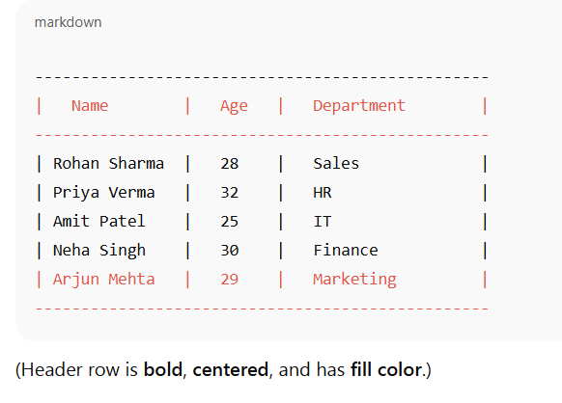

Question 7: Demonstrate how to insert and delete multiple rows and columns in Excel.

Ans:- **nsert Multiple Rows**

1. Select the number of rows you want to insert.  
   * Example: To insert **3 new rows**, select **3 existing rows** (say rows 4–6).
2. Right-click the selection → Click **Insert**.  
   * New blank rows will appear **above** the first selected row.

👉 Shortcut: Press **Ctrl + Shift + "+"** after selecting rows.

### **Insert Multiple Columns**

1. Select the number of columns you want to insert.  
   * Example: To insert **2 new columns**, select **2 existing columns** (say columns B & C).
2. Right-click → Click **Insert**.  
   * New blank columns will appear **to the left** of the first selected column.

👉 Shortcut: Press **Ctrl + Shift + "+"** after selecting columns.

## **🔴 Deleting Multiple Rows & Columns**

### **Delete Multiple Rows**

1. Select the rows you want to delete (e.g., rows 8–10).
2. Right-click → Click **Delete**.

👉 Shortcut: Press **Ctrl + “–”** after selecting rows.

### **Delete Multiple Columns**

1. Select the columns you want to delete (e.g., columns D–F).
2. Right-click → Click **Delete**.

👉 Shortcut: Press **Ctrl + “–”** after selecting columns.

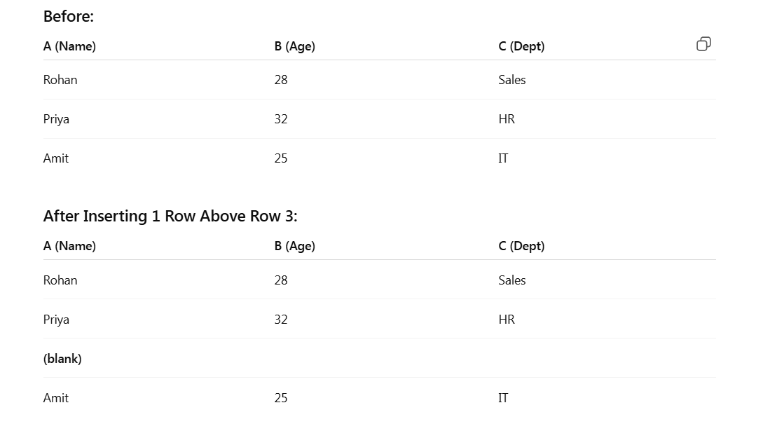

Question 8: Use Excel's 'Find and Replace' feature to update department names in a sample table.

Ans:-

**Step 1: Sample Table**

| **Name** | **Age** | **Department** |
| --- | --- | --- |
| Rohan Sharma | 28 | Sales |
| Priya Verma | 32 | HR |
| Amit Patel | 25 | IT |
| Neha Singh | 30 | Finance |
| Arjun Mehta | 29 | Sales |

## **Step 2: Open Find & Replace**

1. Select the **Department column** (or the whole table if you prefer).
2. Press **Ctrl + H** (this opens the *Find and Replace* dialog).

## **Step 3: Replace Department Names**

* In **Find what:** type Sales
* In **Replace with:** type Marketing
* Click **Replace All**

👉 All "Sales" entries will be updated to "Marketing".

## **Step 4: Updated Table**

| **Name** | **Age** | **Department** |
| --- | --- | --- |
| Rohan Sharma | 28 | Marketing |
| Priya Verma | 32 | HR |
| Amit Patel | 25 | IT |
| Neha Singh | 30 | Finance |
| Arjun Mehta | 29 | Marketing |

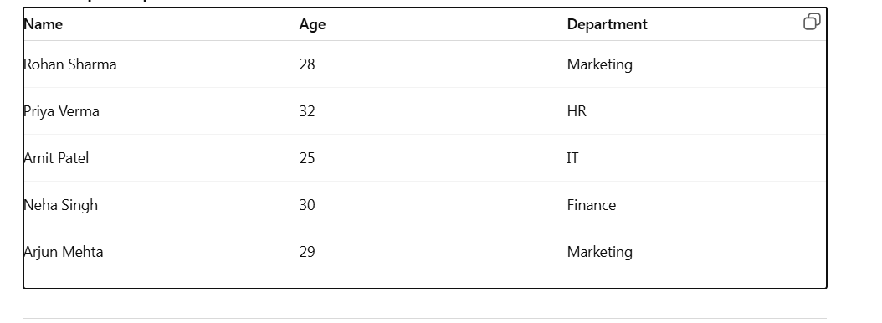

Question 9: Create a small numerical dataset and apply the following functions: ● AVERAGE ● MAX ● MIN

Ans:-

**Step 1: Create a Small Numerical Dataset**

| **Employee** | **Salary** |
| --- | --- |
| Rohan | 35000 |
| Priya | 42000 |
| Amit | 30000 |
| Neha | 50000 |
| Arjun | 38000 |

**Step 2: Apply Functions**

### **1. AVERAGE – to calculate the mean salary**

Formula (in a blank cell, e.g., C2):

=AVERAGE(B2:B6)

👉 Result = **39000**

### **2. MAX – to find the highest salary**

Formula:

=MAX(B2:B6)

👉 Result = **50000**

### **3. MIN – to find the lowest salary**

Formula:

=MIN(B2:B6)

👉 Result = **3000**

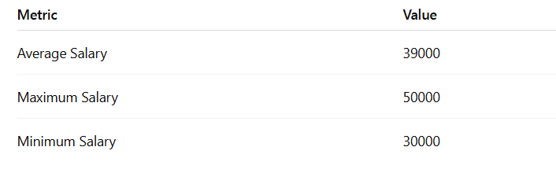

Question 10: You're working with a dataset that contains missing values. As a Data Scientist, explain how you'd detect and handle missing data using Excel. Mention tools like: ● Go To Special ● ISBLANK ● COUNTBLANK

Ans:- **Detecting Missing Data**

### **1. Go To Special**

* Select your dataset.
* Press **F5** → Click **Special…** → Choose **Blanks** → OK.
* Excel will **highlight all blank cells** in the selected range.  
   👉 Useful when you want to visually spot and then fill missing values.

### **2. ISBLANK Function**

Formula:  
  
 =ISBLANK(A2)

* Returns **TRUE** if cell A2 is blank, otherwise **FALSE**.  
   👉 Helps check missing values row by row.

### **3. COUNTBLANK Function**

Formula:  
  
 =COUNTBLANK(A2:A10)

* Counts the total number of blank cells in the given range.  
   👉 Useful to quickly know how many missing values exist.

**Handling Missing Data**

1. **Delete Rows/Columns with Missing Data**
   * If blanks are very few and not important, simply delete them.
2. **Replace with Zero or a Fixed Value**
   * Select blanks → Right-click → Fill with 0 or another constant.
3. **Fill with Above/Below Value**
   * Use **Ctrl + D** (fill down) or **Ctrl + R** (fill right).
4. **Replace with Mean/Median (for numerical data)**
   * Calculate mean/median using =AVERAGE(range) or =MEDIAN(range)
   * Fill blanks with that value.
5. **Use Conditional Formatting**
   * Highlight blanks (via **Home → Conditional Formatting → New Rule → Use a formula → =ISBLANK(A2)**).
   * This visually flags missing data.

# COUNTBLANK(B2:B6) → **2 blanks** in Age.

* COUNTBLANK(C2:C6) → **1 blank** in Salary.
* Use **Go To Special → Blanks** to highlight them, then decide whether to delete or fill.

